**WEB DEVELOPMENT FOR HYPERLOCAL MARKET**

This winter internship project A report Submitted to department of

Computer technology

(PRIYADARSHINI COLLEGE OF ENGINEERING)

In partial fulfilment of the requirement

FOR the WINTER INTERNSHIP PROGRAM

By

ABHIJEET SATPUTE

Under the esteemed guidance of

MR.KRUNAL KALBENDE

CEO (COJAG)

Cojag smart technology Pvt. Ltd



Department of Computer Technology

PRIYADARSHINI COLLEGE OF ENGINEERING

2018-2019

Contents

|  |  |
| --- | --- |
| **Topic** | **Page No** |
| * Scratch Programming | 3 |
| * HTML | 5 |
| * CSS | 7 |
| * PHP Programming | 9 |
| * XAMPP | 14 |
| * Ethical Hacking | 15 |
| * Thunkable app | 17 |
| * Python | 19 |
| * Arduino UNO | 20 |
| * Project (Website Development) | 28 |
| * Conclusion | 35 |

**SCRATCH PROGRAMMING**

Scratch is a visual programming language and online community targeted primarily at children. Using Scratch, users can create online projects and make them into anything by coding with simple blocksEIJ. When they are done or when the desire to, they then share and can discuss their creations with each other.

Developed by the Lifelong Kindergarten group at the MIT Media Lab the service is designed to help learn to imagine, reason with common sense, and work with computers.

Teachers also use it as a tool across many other subjects including math, science, history, geography, and art. As of May 2018, there were more than 31,932,249 projects shared, 28,361,710 users registered, 156,310,759 comments posted, 4,533,610 studios created. The blocks-based grammar of Scratch has influenced many other programming environments and is now considered a standard for introductory coding experiences.

**EDUCATIONAL USE:**

Scratch was made popular in the United Kingdom through Code Clubs. Scratch is used as the introductory language because creation of interesting programs is relatively easy, and skills learned can be applied to other basic programming languages such as Python and Java.

Scratch is not exclusively for creating games. With the provided visuals, programmers can create animations, text, and more.

There are already many programs which students can use to learn topics in math, history, and even photography. Scratch flexibility allows teachers to create conceptual and visual lessons and science lab assignments, as Scratch is a useful tool to create animations that help visualize difficult concepts such as plant cell mitosis, the water cycle, Galileo Thermometer or Hooke's Law Experiment.

Within the social sciences, instructors can create quizzes, games, and tutorials that stimulate the mind and interact with the student. Using Scratch allows young people to understand the logic of programming and how to creatively build and collaborate.

Scratch lets students create "meaningful personal as well as educational projects" which gives students a "practical tool" to express themselves after learning to use the language.

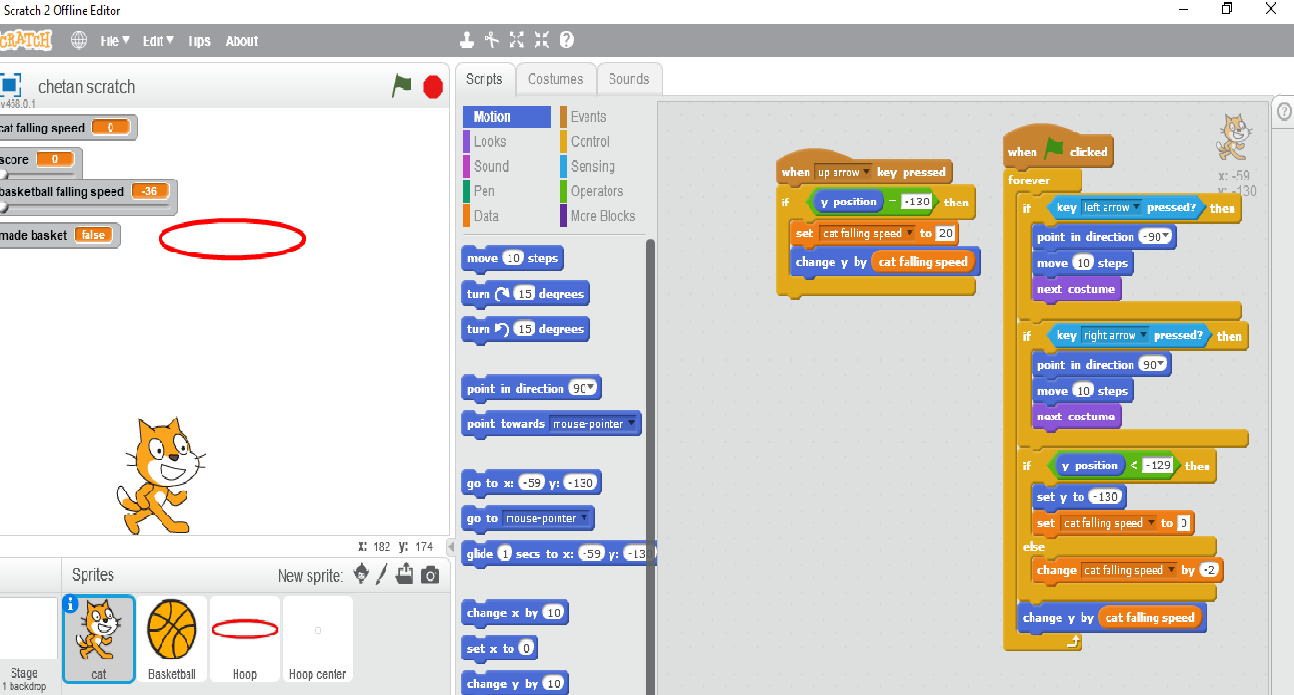

**HTML PROGRAMMING**

Hypertext Markup Language (HTML) is the standard markup language for creating web pages and web applications. With Cascading Style Sheets (CSS) and JavaScript, it forms a triad of cornerstone technologies for the World Wide Web.

Web browsers receive HTML documents from a web server or from local storage and render the documents into multimedia web pages. HTML describes the structure of a web page semantically and originally included cues for the appearance of the document.

HTML elements are the building blocks of HTML pages. With HTML constructs, images and other objects such as interactive forms may be embedded into the rendered page. HTML provides a means to create structured documents by denoting structural semantics for text such as headings, paragraphs, lists, links, quotes and other items. HTML elements are delineated by tags, written using angle brackets. Tags such as <imp /> and <input /> directly introduce content into the page. Other tags such as <p> surround and provide information about document text and may include other tags as sub-elements. Browsers do not display the HTML tags but use them to interpret the content of the page.

HTML can embed programs written in a scripting language such as JavaScript, which affects the behaviour and content of web pages. Inclusion of CSS defines the look and layout of content. The World Wide Web Consortium (W3C), maintainer of both the HTML and the CSS standards, has encouraged the use of CSS over explicit presentational HTML since 1997.

HTML is the standard markup language for creating Web pages.

* HTML stands for Hyper Text Markup Language
* HTML describes the structure of Web pages using markup
* HTML elements are the building blocks of HTML pages
* HTML elements are represented by tags
* HTML tags label pieces of content such as "heading", "paragraph", "table", and so on
* Browsers do not display the HTML tags but use them to render the content of the page.

Examples: -

<!DOCTYPE html>

<html>

<head>

<title>Page Title</title>

</head>

<body>

<h1>This is a Heading</h1>

<p>This is a paragraph. </p>

</body>

</html>

**CSS PROGRAMMING**

Cascading Style Sheets (CSS) is a style sheet language used for describing the presentation of a document written in a markup language like HTML.CSS is a cornerstone technology of the World Wide Web, alongside HTML and JavaScript.

CSS is designed to enable the separation of presentation and content, including layout, colors, and fonts. This separation can improve content accessibility, provide more flexibility and control in the specification of presentation characteristics, enable multiple web pages to share formatting by specifying the relevant CSS in a separate .css file, and reduce complexity and repetition in the structural content.

Separation of formatting and content also makes it feasible to present the same markup page in different styles for different rendering methods, such as on-screen, in print, by voice (via speech-based browser or screen reader), and on Braille-based tactile devices. CSS also has rules for alternate formatting if the content is accessed on a mobile device.

The name cascading comes from the specified priority scheme to determine which style rule applies if more than one rule matches a particular element. This cascading priority scheme is predictable.

The CSS specifications are maintained by the World Wide Web Consortium (W3C). Internet media type (MIME type) text/css is registered for use with CSS by RFC 2318 (March 1998). The W3C operates a free CSS validation service for CSS documents.

**Example: -**

body {

background-color: lightblue;

}

h1 {

color: white;

text-align: center;

}

p {

font-family: verdana;

font-size: 20px;

}

**PHP Programming**

**What is PHP?**

PHP is an acronym for "PHP: Hypertext Preprocessor"

PHP is a widely-used, open source scripting language

PHP scripts are executed on the server

PHP is free to download and use

**What is a PHP File?**

PHP files can contain text, HTML, CSS, JavaScript, and PHP code

PHP code are executed on the server, and the result is returned to the browser as plain HTML

PHP files have extension ".php"

**What Can PHP Do?**

PHP can generate dynamic page content

PHP can create, open, read, write, delete, and close files on the server

PHP can collect form data

PHP can send and receive cookies

PHP can add, delete, modify data in your database

PHP can be used to control user-access

PHP can encrypt data

With PHP you are not limited to output HTML. You can output images, PDF files, and even Flash movies. You can also output any text, such as XHTML and XML.

**Why PHP?**

PHP runs on various platforms (Windows, Linux, Unix, Mac OS X, etc.) PHP is compatible with almost all servers used today (Apache, IIS, etc.)

PHP supports a wide range of databases

PHP is free. Download it from the official PHP resource: www.php.net

PHP is easy to learn and runs efficiently on the server side

here are two ways the browser client can send information to the web server.

The GET Method

The POST Method

Before the browser sends the information, it encodes it using a scheme called Ulil encoding. In this schernr!, name/value pairs are joined with equal signs and different pairs are separated by the ampersand.

namei-value1Aname2-value2tnarne3wva1ue3

Spaces are removed and replaced with the 4- character and any other nonalphanumeric characters are replaced with a hexadecimal values. After the information is encoded it is sent to the server,

The GET Method

The GET method sends the encoded user information appended to the page request, The page and the encoded information are separated by the ? character,

http://v,r4.test, com/index,htm?narne1.-value1Znarne2svalue2

The GET method produces a long string that appears in your server logs, in the browsers Location: box,

The GET method is restricted to send upto 1024 characters only,

Never use GET method if you have password or other sensitive information to be sent to the server.

GET can't be used to send binary data, like images or word documents, to the server,

The data sent by GET method can be accessed using QUERY_STRING environment variable.

The PHP provides $_GET associative array to access all the sent information using GET method.

Try out following example by putting the source code in test,php script,

<?php

if( $_GET("name") II $_GET["age"] ) {

echo "Welcome ". S_GET[gname.]. "<br />";

echo "You are ". $_GETPagel]. " years old.";

exit();

}

?>

<html>

<body>

<form action = "<?php S_PHP_SELF ?>" method = "GET": Name: <input type = "text" name = "name" /> Age: <input type = "text" name = "age" I> <input type = "submit" I> </form>

</body>

</html>

It will produce the following result -

Name:

Age :

Submit

The POST Method

The POST method transfers information via HTTP headers. The information is encoded as described in case of GET method and put into a header called QUERY_STRING,

The POST method does not have any restriction on data size to be sent141.

The POST method can be used to send ASCII as well as binary data,

The data sent by POST method goes through HTTP header so security depends on HTTP protocol. By using Secure HTTP you can make sure that your information is secure.

The PHP provides $_POST associative array to access all the sent information using POST method.

Try out following example by putting the source code in test.php script.

<?php

if( $_POSTrname"1 I S_POST["age] ) {

if (preg_matchr/[^A-Za-z'-]/",$_POSTUname1) )) {

die ("invalid name and name should be alpha");

}

echo "Welcome ". S_POST[Inamel]. "<br />";

echo "You are ". $_POSTragel. " years old.";

exit();

?>

<html>

<body>

<form action = "<?php $_PHP_SELF ?>" method = "POST">

Name: <input type = "text" name = "name" />

Age: <input type = "text" name = "age" I>

<input type = "submit" I>

</form>

</body>

</html>

It will produce the following result —

Name:

Age:

Submit

**XAMPP**

Xampp is a free and open source cross-platform web server solution stack package developed by Apache Friends, consisting mainly of the Apache HTTP Server, MariaDB database, and interpreters for scripts written in the PHP and Perl programming languages. XAMPP stands for Cross-Platform (X), Apache (A), MariaDB (M), PHP (P) and Perl (P). It is a simple, lightweight Apache distribution that makes it extremely easy for developers to create a local web server for testing and deployment purposest5). Everything needed to set up a web server — server application (Apache), database (MariaDB), and scripting language (PHP) — is included in an extractable file. XAMPP is also cross-platform, which means it works equally well on Linux, Mac and Windows. Since most actual web server deployments use the same components as XAMPP, it makes transitioning from a local test server to a live server extremely easy as well.

Examples: -

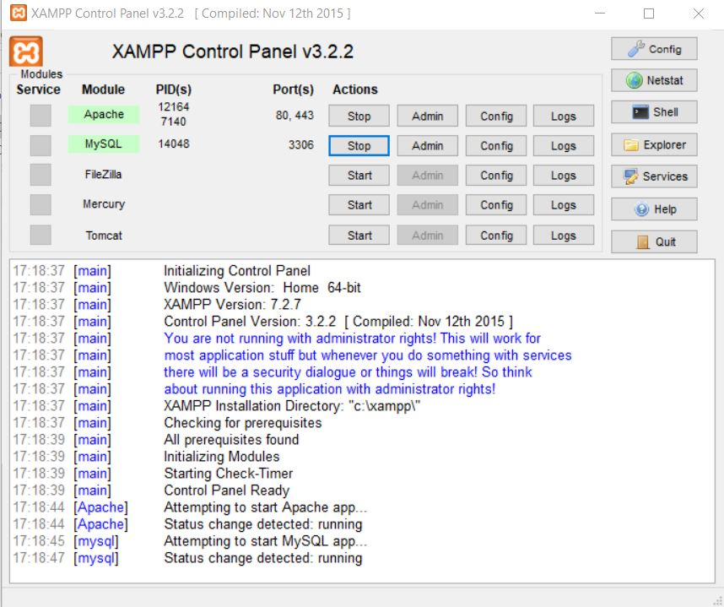

**Ethical Hacking**

**Ethical hacking is identifying weakness in computer systems or networks to exploit its weaknesses to gain access.** Example of Hacking: Using password cracking algorithm to gain access to a system

Computers have become mandatory to run a successful businesses. It is not enough to have isolated computers systems; they need to be networked to facilitate communication with external businesses. This exposes them to the outside world and hacking. Hacking means using computers to commit fraudulent acts such as fraud, privacy invasion, stealing corporate/personal data, etc. Cyber-crimes cost many organizations millions of dollars every year. Businesses need to protect themselves against such attacks.

**Advantages of ethical hacking**

**Testing Security Measures**

The primary advantage of having ethical hackers on a company's payroll is that the hackers are allowed to test a company's security measures in a controlled, safe environment. These hackers can help companies determine which of their computer security measures are effective, which measures need updating, and which ones pose little to no deterrent to dangerous intruders. The data from these tests allows management to make informed decisions on where and how to improve their information security.

**Finding Vulnerable Areas**

When the white-hat hackers finish exploring the company's system, they turn in a report on the system's vulnerable areas. These areas can be related to the technology, such as a lack of sufficient password encryption, or in human-based systems, such as administrators who give out passwords to unauthorized personnel. The exposure of these vulnerabilities allows management to install more secure procedures to prevent attackers from exploiting either the computer networks or the mistakes of their own personnel.

**Understanding Hacker Techniques**

White hat hackers can also demonstrate the techniques used by unethical invaders. These demonstrations serve to show management how thieves, terrorists and vandals can attack their systems and destroy their businesses. When management has a firm grasp on the concepts that black hat hackers use, they can also learn how to prevent those invaders from using those techniques to penetrate their vulnerable systems.

**Preparing for a Hacker Attack**

Businesses that handle sensitive data must understand that they serve as potential targets of a hacker attack. Smaller companies that lack the resources for adequate network security present black-hat hackers with tempting targets of opportunity. These attacks can cripple or destroy small businesses as much as a fire or a natural disaster.

**Disadvantages of Ethical Hacking**

As with all types of activities which have a darker side, there will be dishonest people presenting drawbacks. The possible drawbacks of ethical hacking include:

• The ethical hacker using the knowledge they gain to do malicious hacking activities

• Allowing the company's financial and banking details to be seen • The possibility that the ethical hacker will send and/or place malicious code, viruses, malware and other destructive and harmful things on a computer system

• Massive security break.

**Thunkable Android**

What is a procedure in Thunkable? An Thunkable procedure collects a sequence of blocks together into a group. You can then use the sequence of blocks repeatedly by calling the procedure. If the procedure has arguments, you specify the arguments by using name blocks. When you create a procedure, Thunkable automatically generates a call block and places it in the My Definitions drawer. You use the call block to invoke the procedure.

When you create a new procedure block, Thunkable chooses a unique name automatically. You can click on the name and type to change it. Procedure names in an app must be unique. Thunkable will not let you define two procedures in the same app with the same name. You can rename a procedure at any time while you are building the app, by changing the label in the block. Thunkable will automatically rename the associated call blocks to match.

Let's build a procedure to do the job of the redundant code blocks. In Thunkable, you define a procedure in a manner similar to how you define variables. From the Procedures drawer, drag out either a procedure do block or a to procedure return block. Use the latter if your procedure should calculate some value and return it. After dragging out a procedure block, you can change its name from the default "procedure" by clicking the word "procedure" and typing the new name.

In a game we built called MoleMash, you can create a procedure called MoveMole to move the mole to a random location on the screen.

After you create a procedure, a block is put in the Built-In Procedures drawer that lets you call your procedure.

Additional details on Thunkable's procedure blocks can be found on the Procedure Blocks page.

What is an argument? An argument is an input to our procedure. Some procedures require knowing some bits of information that change how the procedure is run. Let's look at the banana bread recipe example. Sometimes the baker may want to make two loaves of banana bread. Then the baker would double the amount of each ingredient

**PYTHON**

Python is an interpreted high-level programming language for general-purpose programming. Created by Guido van Rossum and first released in 1991, Python has a design philosophy that emphasizes code readability, notably using significant whitespace. It provides constructs that enable clear programming on both small and large scales.

Python features a dynamic type system and automatic memory management. It supports multiple programming paradigms, including object-oriented, imperative, functional and procedural, and has a large and comprehensive standard library.

Python interpreters are available for many operating systems. CPython, the reference implementation of Python, is open source software. and has a community-based development model, as do nearly all of its variant implementations. CPython is managed by the non-profit Python Software Foundation.

Examples: -

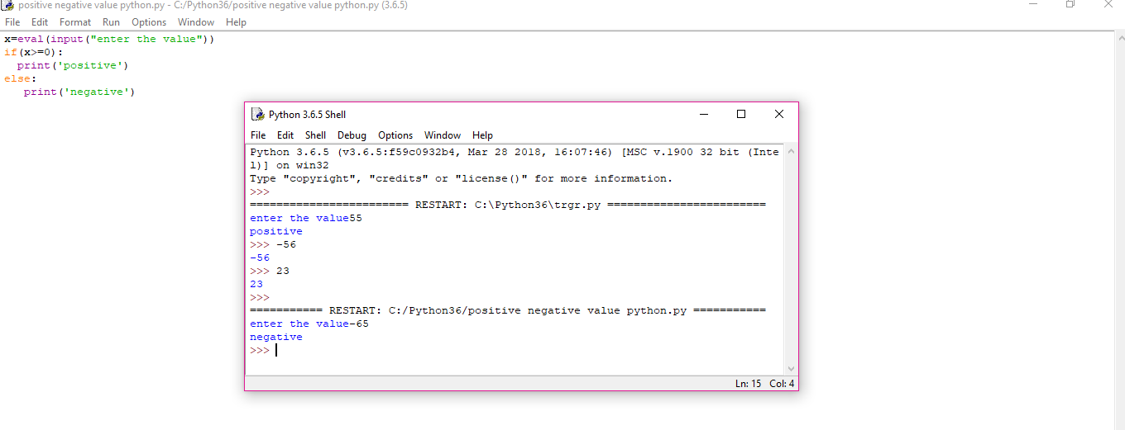

**ARDUINO UNO**

Arduino Uno is a microcontroller board based on the ATmega328P (datasheet). It has 14 digital input/output pins (of which 6 can be used as PWM outputs), 6 analogy inputs, a 16 MHz quartz crystal, a USB connection, a power jack, an ICSP header and a reset button.

The Arduino Uno is a microcontroller board based on the ATmega328. It has 20 digital input/output pins (of which 6 can be used as PWM outputs and 6 can be used as analogy inputs), a 16 MHz resonator, a USB connection, a power jack, an in-circuit system programming (ICSP) header, and a reset button.

Arduino board designs use a variety of microprocessors and controllers. The boards are equipped with sets of digital and analogy input/output (I/O) pins that may be interfaced to various expansion boards or Breadboards (shields) and other circuits. The boards feature serial communications interfaces, including Universal Serial Bus (USB) on some models, which are also used for loading programs from personal computers. The microcontrollers are typically programmed using a dialect of features from the programming languages C and C++.

The name Arduino comes from a bar in Ivrea, Italy, where some of the founders of the project used to meet. The bar was named after Arduino of Ivrea, who was the margrave of the March of Ivrea and King of Italy from 1002 to 1014.

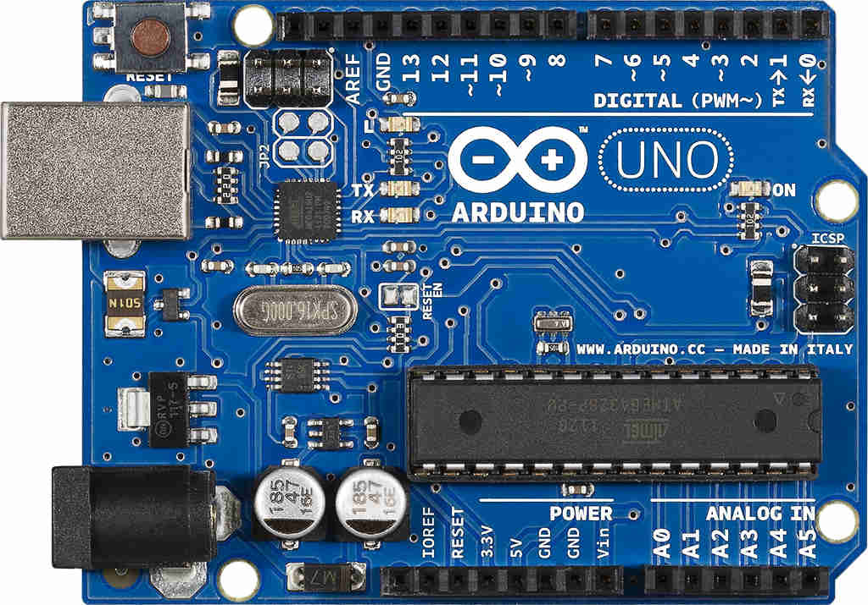

**FIG.1**

Led blink using Arduino:

Here we are going to write a program to blink an LED for every 500ms. In ArduinoUno, a LED will be already designed at the pin13, but we are not going to use it. Here we are going to connect an indicating LED to PIN0 through a current limiting resistor.

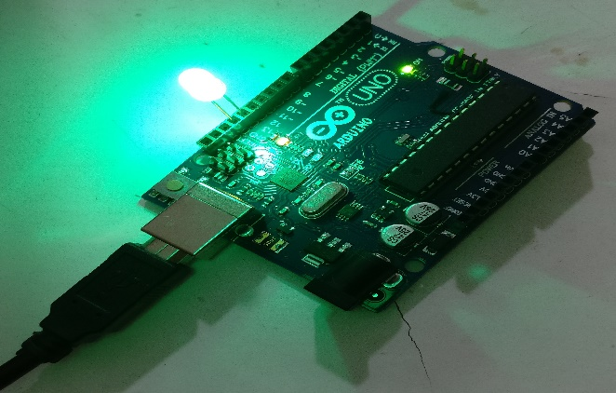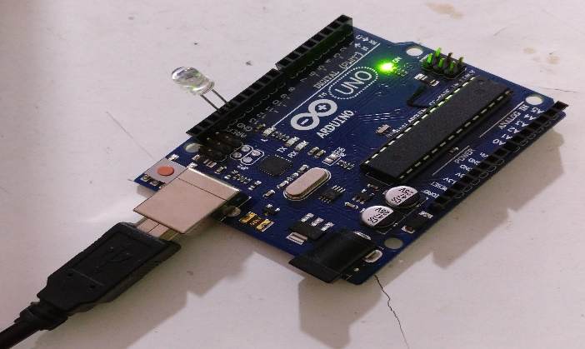

**FIG.2**

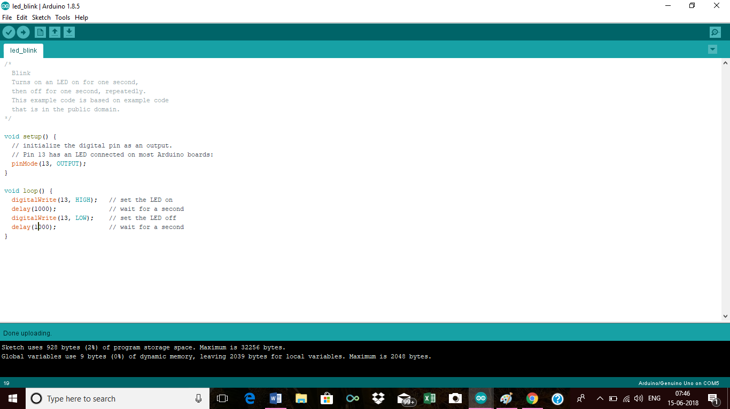

**FIG.3**

Temperature sensor using Arduino:

A temperature sensor is exactly what it sounds like – a sensor used to measure ambient temperature. This particular sensor has three pins – a positive, a ground, and a signal. This is a linear temperature sensor. A change in temperature of one degree centigrade is equal to a change of 10 millivolts at the sensor output.

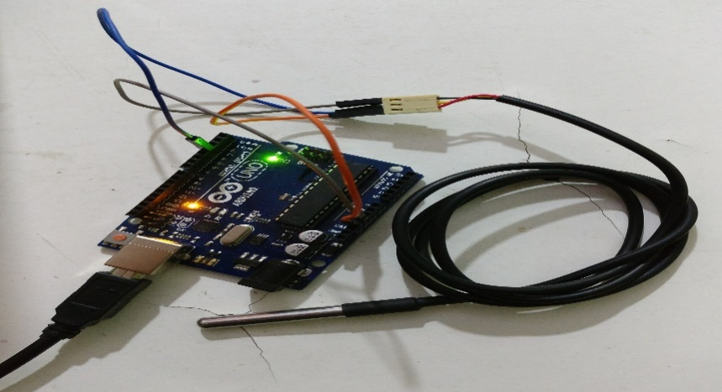

**FIG.4**

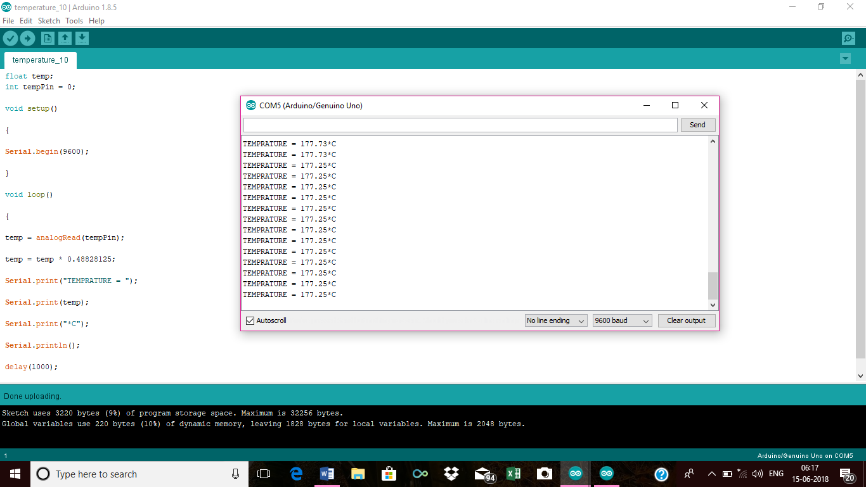

**FIG.5**

Soil moisture sensor using Arduino:

In this article, we are going to interface a Soil moisture sensor FC-28 with Arduino. This sensor measures the volumetric content of water inside the soil and gives us the moisture level as output. The sensor is equipped with both analogue and digital output, so it can be used in both analogue and digital mode. In this article, we are going to interface the sensor in both modes. So, let’s begin our tutorial on interfacing Arduino and Soil moisture.

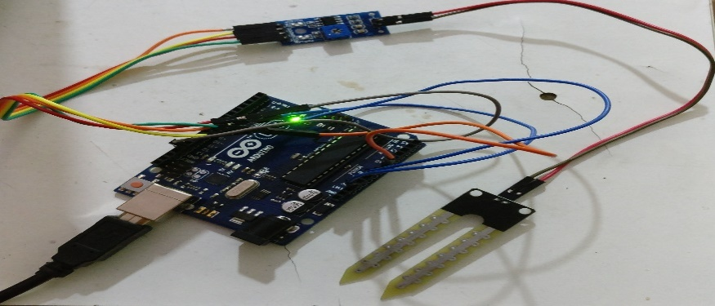

**FIG.6**

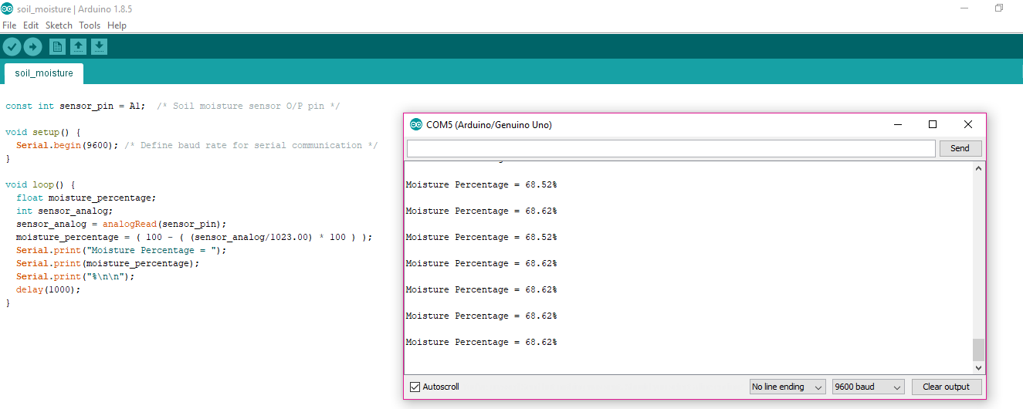

**FIG.7**

Servo motor using Arduino:

Servo motors are great devices that can turn to a specified position. Usually, they have a servo arm that can turn 180 degrees. Using the Arduino, we can tell a servo to go to a specified position and it will go there. As simple as that! Servo motors were first used in the Remote Control (RC) world, usually to control the steering of RC cars or the flaps on a RC plane. With time, they found their uses in robotics, automation, and of course, the Arduino world.

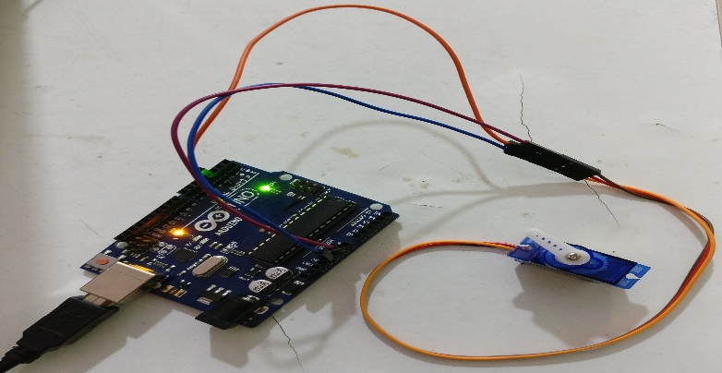

**FIG.8**

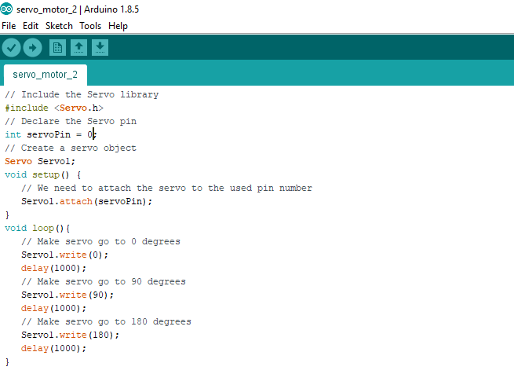

**FIG.9**

Ultrasonic sensor using Arduino:

The HC-SR04 ultrasonic sensor uses SONAR to determine the distance of an object just like the bats do. It offers excellent non-contact range detection with high accuracy and stable readings in an easy-to-use package from 2 cm to 400 cm or 1” to 13 feet.

The operation is not affected by sunlight or black material, although acoustically, soft materials like cloth can be difficult to detect. It comes complete with ultrasonic transmitter and receiver module.

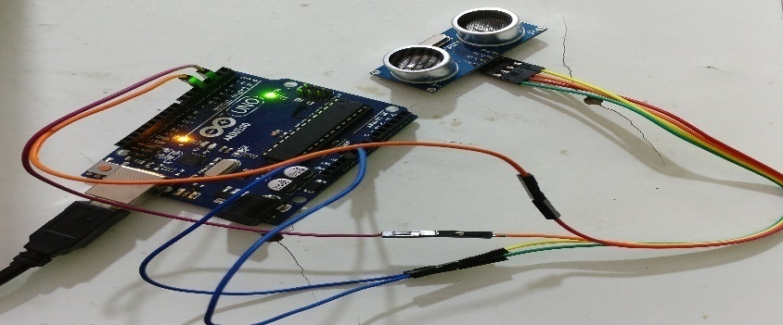

**FIG.10**

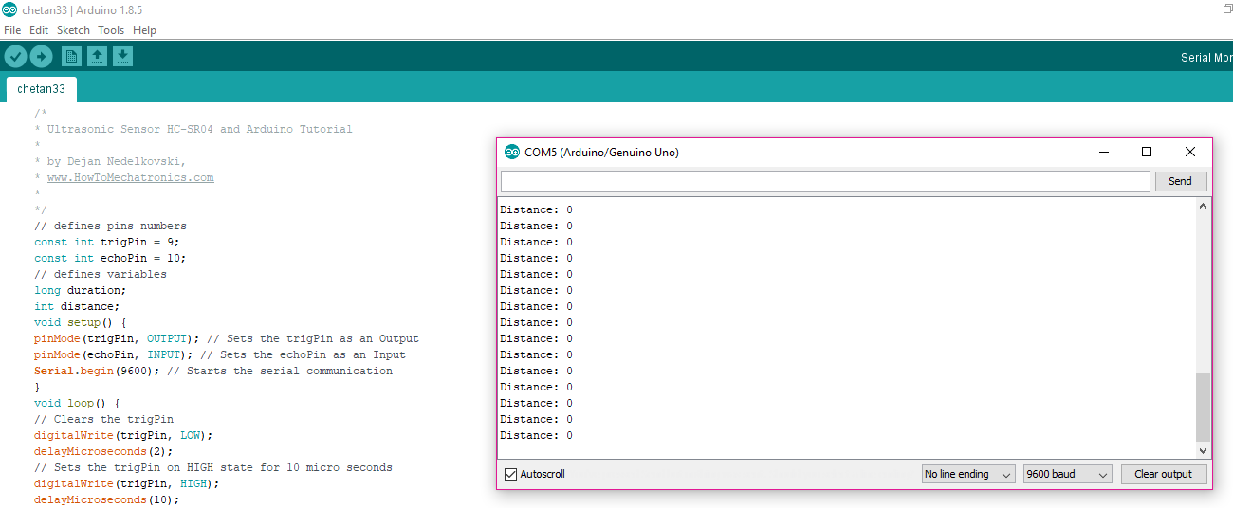

**FIG.11**

GSMMODULEKIT USING ARDUINO:

There are different kinds of GSM modules available in market. We are using the most popular module based on **Simcom SIM900** and **Arduino Uno**. Interfacing a GSM module to Arduino is pretty simple. You only need to make 3 connections between the gsm module and Arduino. So,let’s get to business!

A **GSM Module** is basically a GSM Modem (like SIM 900) connected to a PCB with different types of output taken from the board – say TTL Output (for Arduino, 8051 and other microcontrollers) and RS232 Output to interface directly with a PC (personal computer). The board will also have pins or provisions to attach mic and speaker, to take out +5V or other values of power and ground connections. These types of provisions vary with different modules.

Lots of varieties of GSM modem and GSM Modules are available in the market to choose from. For our project of connecting a gsm modem or module to Arduino and hence send and receive SMS using Arduino – it’s always good to choose an***Arduino compatible GSM Module*** – that is a GSM module with TTL Output provisions. Shown in figure 12.

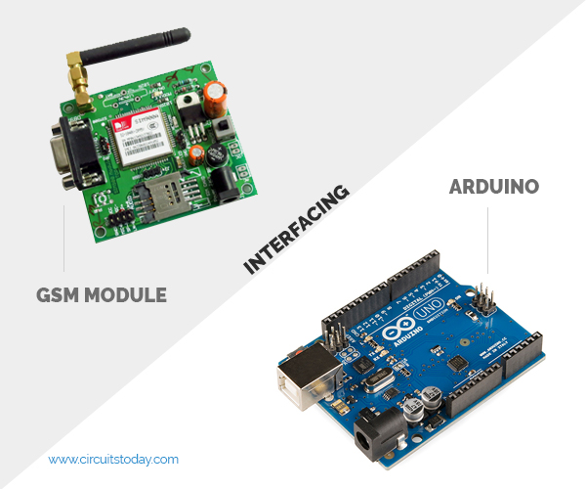

**FIG.12**

Node mcu:

NodeMCU is an open source LUA based firmware developed for ESP8266 Wi-Fi chip. By exploring functionality with ESP8266 chip, NodeMCU firmware comes with ESP8266 Development board/kit i.e. NodeMCU Development board.

Since NodeMCU is open source platform, their hardware design is open for edit/modify/build.

NodeMCU Dev Kit/board consist of ESP8266 Wi-Fi enabled chip. The ESP8266 is a low-cost Wi-Fi chip developed by Espressif Systems with TCP/IP protocol. For more information about ESP8266, you can refer ESP8266 Wi-Fi Module.

There is Version2 (V2) available for NodeMCU Dev Kit i.e. NodeMCU Development.

Board v1.0 (Version2), which usually comes in black colored PCB.

For more information about NodeMCU Boards available in market refer NodeMCU Development Boards

NodeMCU Dev Kit has Arduino like Analog (i.e. A0) and Digital (D0-D8) pins on its board. It supports serial communication protocols i.e. UART, SPI, I2C etc.

Using such serial protocols, we can connect it with serial devices like I2C enabled LCD display, Magnetometer HMC5883, MPU-6050 Gyro meter + Accelerometer, RTC chips, GPS modules, touch screen displays, SD cards etc.

**PROJECT WORK**

Web Development

This section is intended to guide parties interested in collaborating on web development projects. The reader will walk through the two basic stages of the process: ScopeAssessment and Planning, and Designand Implementation. This section will focus on the theoretical aspects of these two stages, posing possible questions to answer, issues to address, and providing the rationale for some of the behind-the-scenes thinking and planning that goes into a successful web initiative.

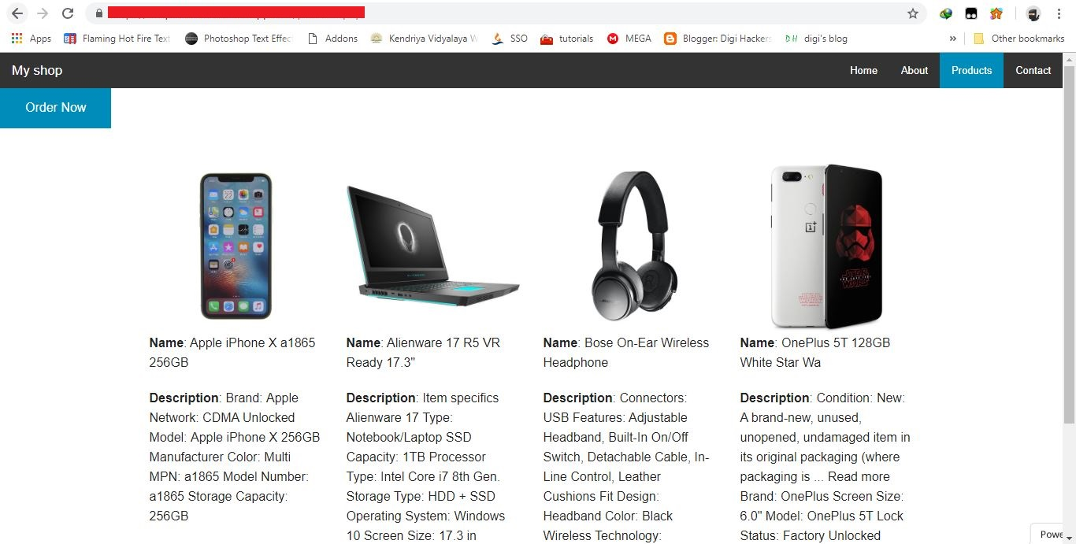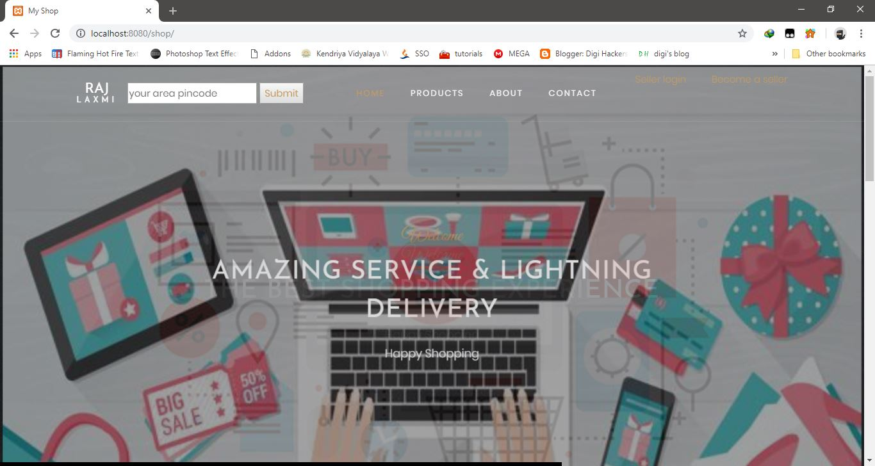

**HYPERLOCAL MARKET**

There has been a paradigm shift in terms of the lifestyle preferences and buying trends among Indian consumers over the last two decades. With the opening, up of the Indian economy, Urban India has gradually embraced consumerism and is increasingly opting for seamless services.

Growing internet penetration and the rise in the number of people using smartphones have acted as a catalyst for the hyperlocal sector while reshaping customer behaviour and expectations. Along with this, increasing disposable incomes, the rise in aspirational values of the consumer, urbanization, and change in technology have also contributed to a booming hyperlocal e-commerce. Also, there is an increase in the young population who believe in ‘Working hard and living stress-free’. They, too, are responsible for the spurt in activity in this sector.

Talking of the Hyperlocal e-commerce industry in India, it has been significantly driven by growing number of start-ups”, enhanced investments and “on-demand delivery preference”.

According to the research report, the India Hyperlocal market will grow at a considerable CAGR rate thus exceeding INR 2,306 crore by 2020. Increasing urbanization, personalization of affinities along with the ability to curate products that appeal to the aesthetic sensibilities or aspirational desires of the person will lead to the rise in the Hyperlocal market in India.

The latest buzz today word is “Hyperlocal”. Diversity in cultures, backgrounds, communities and the vast Indian landscape is geographically divided by these and a rich heritage, but convenience and emotions are still the main driving forces that help build businesses which serve the varied communities of the country. Today, India’s is going Hyperlocal; and people are embracing this new and dynamic marketplace, as it provides them with all things traditional and modern. By 2020, India will move on hyperlocal platforms with company’s such as Cre8comm with OEM’s, digital and hi-tech realms of the business; while maintaining the same bond with customers.

In the recent past, until malls and e-commerce took over our lives, the local Kirana and the scores of mom-and-pop stores served the areas in and around our homes. They had a geographical area that they catered to and were well versed with the families dotted in their delivery route. Company’s such as Cre8comm are built on the same emotions and relationships, only their geographical areas are extended to multiple cities and communities across the country. While cities such as Chennai and Kolkata still thrive on these old bonds and ties built over years. It has used these very same ties to generations of familial bonds between the store and the new age youth and reinvented the customer journey. Thus, forever changing the dynamics in relationships fostered to a much larger community driven platform engaging with the customer in a more personalized and detailed manner.

With the advent e-commerce and digitization; modern families have not attached to the old Kiranas anymore; they prefer to shop from large format stores and supermarkets. But India is a land built on nationalism, bonds, and emotional relationships between communities. If we were to predict how the next few years would pan out to be in this realm of the communities’ businesses, we would be thriving on the same relationships created years ago. Only, these relationships would have evolved and e-commerce would be your newly acquired Kirana.

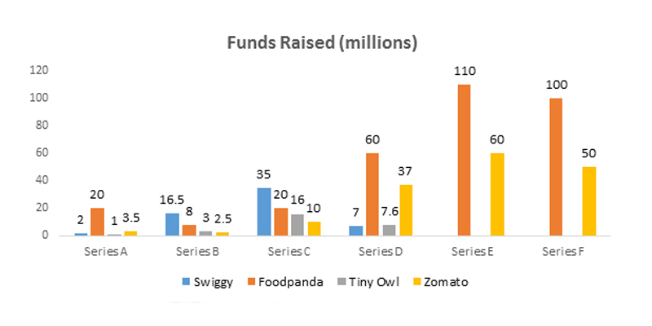

The report titled "**India Hyperlocal Market Outlook to 2020 - Driven by Surge in Number of Startups and Series of Funding**" provides a comprehensive analysis of the various aspects such as market size of the India Hyperlocal Market, Logistics, Food, Groceries, Pharmacy, Horizontal and Concierge. The report covers various aspects such as market size of India hyperlocal market, segmentation on the basis of regions, orders and revenue, by time of delivery, trends and developments, SWOT analysis, BCG Matrix, pre-requisites to enter the market and success and failure case studies of various Hyperlocal companies in the country. The report also provides market share, business strategies, month-on-month order growth and key performance indicators of major companies in horizontal hyperlocal, food technology, grocery, pharmacy, concierge segment. The report also provides future analysis of overall hyperlocal market of India and its segments. The report is useful for Hyperlocal vendors, investors and funding institutions, E-commerce companies and new players venturing in the market.

**India Hyperlocal Market**  
Hyperlocal market in India, which is driven by sales of Logistics, Food, Groceries, registered revenues of INR ~ million in 2015. Even with the advent of new startups in the industry, the revenues increased by 41% compared to 2014 where the total revenues were registered as INR ~ million. The Hyperlocal market in India has grown at a growth rate of 71% in number of orders from ~ million in 2014 to ~ million in 2015.

The Hyperlocal industry in India is comprised of various segments such as Logistics, Food, Groceries, Pharmacy, Horizontal and Concierge segment that comprises of various companies in the Hyperlocal market in India. The horizontal hyperlocal market has remained largest contributor to the hyperlocal market with share of ~% in overall market revenues followed by food hyperlocal market registering share of ~% in the revenues in 2015. In addition to this, Bangalore and Delhi have been the home to various Hyperlocal startups due to ease in transportation and infrastructure facilities. Delhi accounted for ~% of the overall hyperlocal market order in December 2015 followed by Bangalore with ~% share in the total number of orders. The India Hyperlocal market will grow at a considerable CAGR rate thus exceeding INR ~ million by 2020.

**India Logistics Hyperlocal Market**  
The hyperlocal logistic market in India has intensified at a healthy growth rate in the recent past and has provided a sound platform for the new entrants as well as the budding firms in the market space. The market for logistics hyperlocal in India has registered revenues of INR ~ million in 2015, registering a continuous incline from January 2015 to December 2015. Indian logistic hyperlocal market has witnessed presence of large number of players. Hyperlocal Logistics market in the country has majorly been driven by various players such as Roadrunnr, Grab.in, Shadowfax, Opinio, Xpress Runner and others. Roadrunnr has accounted for ~% of the overall market revenues in 2015, followed by Grab.in contribution of ~% towards the overall market revenues.   
In the coming years, logistics hyperlocal market is projected to incline not only in terms of picking up of orders but also delivering essential products such as food, groceries and dairy products. The market revenues of the hyperlocal logistics market has been projected to augment at a CAGR of ~% during the period 2016-2020 and reach INR ~ million by 2020, whereas number of orders in future would witness a rise at a CAGR of ~% during the outlook period (2016-2020).

**India Grocery Hyperlocal Market**  
The market for hyperlocal grocery has changed radically in India in the past few years. The revenues of the hyperlocal market were registered as INR ~ million in 2015 with number of orders being registered at ~ thousand during the same period. The market has seen presence of players such as Grofers, Pepper tap, Go Zopping, Ninja cart and many other players. Grofers had been the leading players in the India Hyperlocal logistics market and captured ~% of the overall market revenues during 2015. PepperTap has been the second largest player operating in the hyperlocal grocery space of India with revenue contribution of ~% to overall market revenues in 2015. The market is expected to witness a rise in the volume growth with an increase in demand per city. The grocery hyperlocal market in India is expected to grow at a CAGR of ~% in the coming years from 2016 to 2020. It has been estimated that the total market size of grocery hyperlocal in the country will increase from INR ~ million in 2016 to INR ~ million in 2020.

**India Food Hyperlocal Market**  
The revenues generated by food hyperlocal market in India augmented rapidly during January 2015 to December 2015 and has been registered as INR ~ million in 2015. The market has witnessed an enhancement in the demand of online food ordering due to the migration of people in the urban areas. The leader in the food hyperlocal market of India is Food Panda, which has commanded a noteworthy market share during 2015, recorded at ~% in terms of market revenues. The market is expected to witness a CAGR of ~% in terms of number of orders and ~% in terms of revenue during the year 2016-2020. Owing to rising intercity migration by professional as well as educational purposes would further lead to amplification in number of order to ~ million in 2020, leading to inclination in revenues to INR ~ million by 2020.

**India Horizontal Hyperlocal Market**  
India horizontal hyperlocal market has recorded the highest demand from consumers in the year 2015. This exponential usage of online horizontal hyperlocal has led to a growth in number of individuals opting out for horizontal hyperlocal services for different usages such as plumbing, electrician, wedding planning and others across the country. The market of horizontal hyperlocal in India has registered revenues of INR ~ million by servicing the ~ thousand requests in 2015. India Horizontal hyperlocal market is largely dominated by two major players, namely Local Oye and Urban Clap. The market is therefore highly concentrated, with Local Oye and Urban Clap collectively contributing ~% of the market revenues in 2015. The market of horizontal hyperlocal in India is projected to witness an incline in revenues from INR ~ million in 2016 to INR ~ million in 2020.

**India Pharmacy Hyperlocal Market**  
India Hyperlocal pharmacy market has been influenced by the presence of firms such as 1mg, PM Health and Life Care, Pluss and others. 1mg has earned revenue worth INR ~ million in 2015 and has a major share in the pharmacy Hyperlocal market. Online purchase of medicines and drugs through doctor’s prescriptions along with recommendations through doctors has led to an increase in demand of pharmacy through online channels in the country at a phenomenal rate. In the coming years (2016-2020), the market for pharmacy hyperlocal is projected to witness rapid rise in number of orders received which in turn would lead to rise in revenues generated by the market from INR ~ million in 2015 to INR ~ million in 2020.

**India Concierge Hyperlocal Market**  
Hyperlocal concierge services involve delivery from both B2B and B2C segments. Delivery within B2B segments involves delivery to various clients (companies, restaurants and others) whereas delivery within B2C segment involves delivery of products to the customers. Concierge Hyperlocal market is majorly based on delivery of volume products in order to enhance the margins. The market registered revenues of INR ~ million in 2015 on account of ~ thousand requests during the period. The market has witnessed presence of several startups such as Godd Service, Joe Hukum, Bhejjo and many other players. In the future the revenue contribution of the market is expected to incline at a swift rate and reach ~% by 2020.

**Conclusion**

Successfully Completed training cum Internship with project for a client with a requirement of Hyper local market website. Also learnt and enhanced my skills on PHP connectivity with the databases, arduino based mini projects, Designing a full fledged website locally by creating an apache server and sql server locally with XAMPP, creating a basic web page using HTML , styling a web page with CSS and building the database tables with SQL and connecting it with PHP for connectivity with the web site built.